Risk Assessment – xxxxxxxxxxxxxxxxx
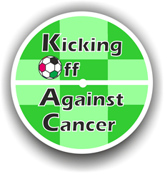 | Schedule:  Build up: Click here to enter text.  Event Open: Click here to enter text.  Break down: Click here to enter text. | Venues:  Click here to enter text.
Event Organiser:  Click here to enter text. | Risk assessment undertaken by:  Click here to enter text. | Distribution:  - Click here to enter text.
 | Date: Click here to enter text.
Scope of Risk Assessment

Hazard | Consequences | Who is at Risk? | P | S | R | Controls Implemented | P | S | R | Remaining Actions
Look only for hazards which you could reasonably expect to result in significant harm. | List the potential impact of the risk to people and the event |  | Probability | Severity | Risk | Have you already taken precautions against the risks from the hazards you listed.  If so, then the risks are adequately controlled, but you need to indicate the precautions you have in place. | Probability | Severity | Risk | What more could you reasonably do for those risks which you found were not adequately controlled?
Example
Vehicles | Crush Injury from Impact | Volunteers/Trustees | 2 | 4 | 8H | Designated parking area to unload equipment. Vehicle keys removed and driver not in vehicle during activity. | 1 | 4 | 4L | None
Event Set Up
During Event
Event Set Down

Risks being Monitored during Event
Hazard | Monitored by | Frequency

